Content Calendar for Bravecto® Plus for Cats – August 2020
Below please find content and images ready for you to use on your practice social media pages to promote Bravecto® Plus for Cats. The text can be copied and pasted from the column on the left and edited as you wish to personalise for your practice.
Post | Asset
Post 1:  There is a new addition to the Bravecto® family – Bravecto® Plus for Cats. This new product still gives your cat the extended 3 months protection against ticks and fleas you have come to love PLUS treatment for roundworms, hookworms, heartworm and ear mites! Stock is available, contact us on *insert practice telephone number* to find our more or to place your order  #BravectoPlus | Image  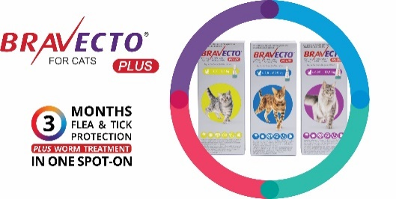  Post 1 Introducing Bravecto Plus
Post 2:  There is an easier way to treat your cats for ticks, fleas and worms, NEW Bravecto® Plus spot-on for cats is now available! 3 months tick and flea protection PLUS worm treatment in 1 spot-on. Contact us today for more information.  #BravecoPlus | Image  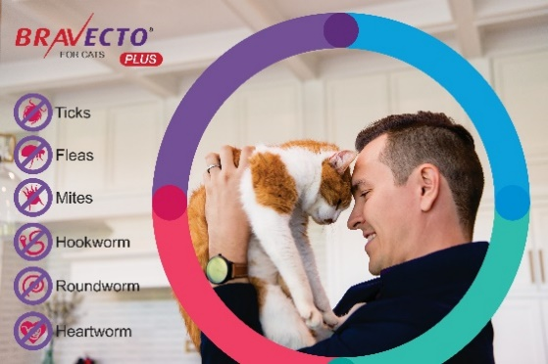  Post 2 Image Easier Way to Treat
Post 3:  How often do you treat your cat for worms? Usually we recommend treatment every 3 months. Now, there’s a simple way – Bravecto® Plus for Cats. One spot-on provides 3 months tick and flea protection PLUS worm and mite treatment. Ask us about Bravecto® Plus today!  #BravectoPlus | Image  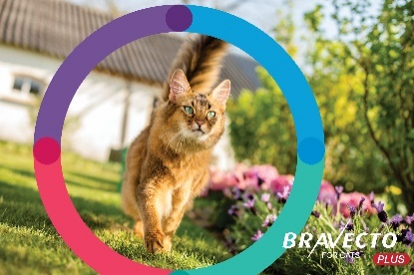  Post 3 Deworming Cats
Post 4:  NEW Bravecto® Plus® for Cats is here and available at our practice. Bravecto® Plus provides 3 months tick and flea protection PLUS treatment against roundworms, hookworms, heartworm and ear mites. Keep your kitty healthy with just 4 doses a year  Contact us on *insert practice telephone number* to get the Bravecto® Plus product suitable for your cat  #BravectoPlus | Video  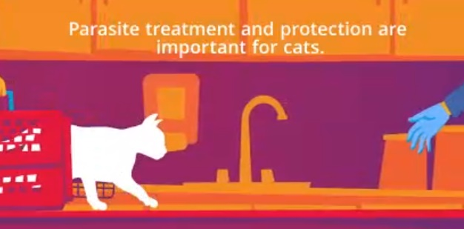  Post 4 Video BravectoPlus The Solution

